THE STORY BEHIND THE POEM
by Joanne Jones, ACT volunteer

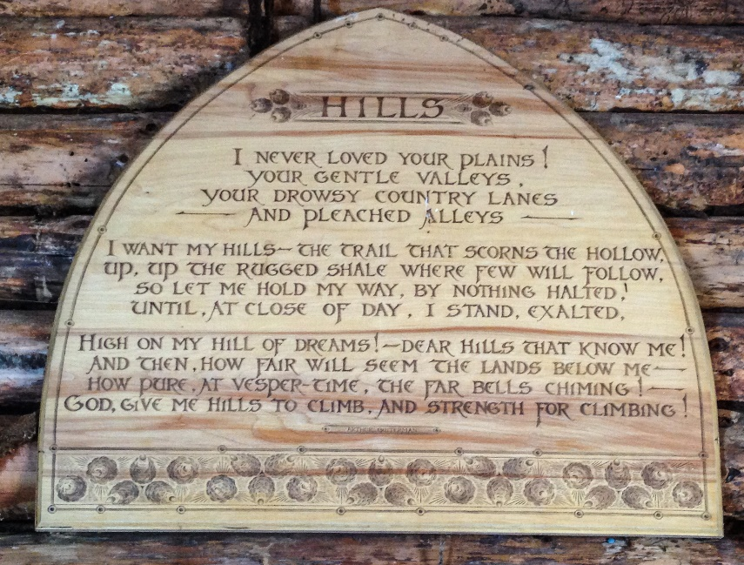

Above the fireplace in the cabin at the Bronson Hill Conservation Area hangs a poem entitled “Hills” that has been enjoyed over the years by visitors to the cabin. I’ve always been intrigued by this poem and, as a former librarian, decided to do some research to learn a little more about the poem and the story behind it. Here’s what I found out!

As noted in small print after the poem and in the Cabin History that hangs on the wall below the poem, the author of the poem is Arthur Guiterman, who lived from 1871 to 1943. Although Guiterman wrote some fiction pieces and articles, he is mainly known for his poems, especially his humorous poetry. He was a prolific author who, over the course of his career, published more than 4000 poems in magazines and newspapers, as well as publishing 15 collections of his poems. The poem “Hills” first appeared in the July 1915 issue of Scribner’s Magazine, a popular magazine in American homes in the early 1900s. It was subsequently republished in the Anthology of Magazine Verse for 1915 and in The Mirthful Lyre, a collection of poems published by Guiterman in 1918.

The Cabin History also mentions that Cornelia Andrews Gibbs loved the poem “Hills” and had it engraved on a wooden plaque for the cabin after the cabin was built in the 1940s. Cornelia’s father was James Frederic Andrews who, in the early 1900s, bought and assembled several parcels of land on Bronson Hill, creating a large farm known as Overlook Farm. She was married to Rufus MacQueen Gibbs and spent summers with her family at the “Bungalette” cottage near the former Sunset Hill House. The Gibbs had four children including a daughter, Marian Hungerford Gibbs. Marian married James H. Perkins and they had three children—Louisa Perkins (Porter), James Perkins, and Rufus Perkins—who are the current owners of the land. Except for a short time period (when Cornelia sold and then later repurchased the farm), the land that was the Overlook Farm has been owned by the Andrews/Gibbs/Perkins family for over 100 years.

To ensure that the fields and woods on Bronson Hill which their family had enjoyed for so many years would always stay in their natural and undeveloped state and be available for the community to enjoy, Louisa, Jim, and Rufus—grandchildren of Cornelia Andrews Gibbs—conserved 120 acres of the land with ACT in 2009, creating the Perkins-Porter Family Preserve. Ten years later, in 2019, Rufus conserved 300 more acres of land on Bronson Hill, creating the conservation property known as Overlook Farm. The Perkins-Porter Family Preserve and Overlook Farm, along with Foss Forest and the MacCornack-Evelyn Forest, now comprise the Bronson Hill Conservation Area that covers over 600 acres on Bronson Hill.

So that is the story behind the poem which, as it turns out, is much more than it might seem at first glance. It is indeed about the publication of a lovely poem, but it is also very much the story of one family’s abiding love for a very special place and their desire to preserve the land they loved so much for future generations to enjoy.

